# **PRD FRONTEND-FOCUSED - HUE DATA CENTER POWER INFRASTRUCTURE DEMO**

🎯 Mục tiêu: Thu hút Tech Giants đầu tư $1-5B với demo website ấn tượng nhất 🎨 80% Frontend (Đẹp & Chuyên nghiệp) + 20% Backend (Functional) tập trung vào visulization phần lưới điện.

## **🏗️ TECH STACK ALLOCATION**

### **🎨 FRONTEND (80% Effort) - STUNNING & PROFESSIONAL**

typescript

Next.js 14 (App Router + Server Components)

├── TypeScript 5.0+ (strict mode + advanced types)

├── Tailwind CSS 3.4 + shadcn/ui + CVA (beautiful UI)

├── Framer Motion 10+ (cinematic animations)

├── Three.js + React Three Fiber + Drei (premium 3D)

├── Recharts + D3.js (stunning visualizations)

├── React Hook Form + Zod (smooth forms)

├── Zustand + Immer (elegant state)

├── TanStack Query (seamless data fetching)

├── Lottie React (micro-animations)

└── GSAP (premium motion graphics)

### **🔧 BACKEND (20% Effort) - SIMPLE BUT FUNCTIONAL**

typescript

*// Minimal but working backend*

NestJS Framework + Fastify (basic setup)

├── MongoDB + Mongoose (simple schemas)

├── Redis (basic caching)

├── WebSocket + Socket.io (real-time simulation)

├── JWT + Passport (basic auth)

└── Docker (containerization)

*// Skip complex features:*

❌ MinIO/S3 (use local storage)

❌ ELK Stack (use console.log)

❌ Prometheus/Grafana (basic metrics only)

❌ Kubernetes (Docker Compose sufficient)

## **1️⃣ SƠ ĐỒ TỔNG THỂ SYSTEM FLOW**

mermaid

graph TB

subgraph "BACKEND SYSTEM"

B1[Data Aggregation Service]

B2[Real-time Simulator]

B3[WebSocket Server]

B4[REST API Gateway]

B5[Authentication Service]

end

subgraph "DATABASE LAYER"

C1[(MongoDB)]

C2[(Redis Cache)]

end

subgraph "FRONTEND WEBSITE"

E1[Landing Page]

E2[3D Power Grid Viewer]

end

end

*%% Data Flow*

A1 --> B1

A2 --> B1

A3 --> B1

A4 --> B1

B1 --> C1

B2 --> C1

B1 --> C2

B3 --> E2

B3 --> E3

B4 --> E1

B4 --> E4

B4 --> E5

C1 --> B4

C2 --> B4

D1 --> C1

D2 --> C1

D3 --> C1

D4 --> C1

D5 --> C1

E1 --> F1

E2 --> F1

E3 --> F1

E4 --> F1

E5 --> F1

style A1 fill:#e1f5fe

style A2 fill:#e1f5fe

style A3 fill:#e1f5fe

style A4 fill:#e1f5fe

style B1 fill:#f3e5f5

style B2 fill:#f3e5f5

style B3 fill:#f3e5f5

style B4 fill:#f3e5f5

style B5 fill:#f3e5f5

style C1 fill:#e8f5e8

style C2 fill:#e8f5e8

style D1 fill:#fff3e0

style D2 fill:#fff3e0

style D3 fill:#fff3e0

style D4 fill:#fff3e0

style D5 fill:#fff3e0

style E1 fill:#e3f2fd

style E2 fill:#e3f2fd

style E3 fill:#e3f2fd

style E4 fill:#e3f2fd

style E5 fill:#e3f2fd

style F1 fill:#fce4ec

style F2 fill:#fce4ec

style F3 fill:#fce4ec

### **System Flow Chi Tiết**

#### **📥 INPUT DATA FLOW**

1. External APIs → Data Aggregation Service → MongoDB
2. Admin Panel → Content Updates → MongoDB
3. Real-time Simulator → WebSocket → Frontend

#### **📤 OUTPUT DATA FLOW**

1. MongoDB → REST API → Frontend Components
2. Redis Cache → Fast Response → Real-time Updates
3. Frontend → Lead Forms → CRM Integration

## **2️⃣ CÁC CHỨC NĂNG CHÍNH**

### **🎨 FRONTEND FEATURES (80% Effort)**

#### **A. HERO & LANDING EXPERIENCE**

* Cinematic Hero Animation
  + 3D Earth zoom vào Vietnam → Huế
  + Power lines materializing animation
  + Live metrics counter animation
  + Particle effects background
* Interactive Navigation
  + Smooth scroll animations
  + Magnetic buttons effects
  + Progressive loading indicators
  + Mobile gesture support

#### **B. 3D POWER GRID VISUALIZATION**

* Interactive 3D Environment
  + Realistic terrain của Huế Hi-Tech Park
  + 500kV transmission lines với animation
  + Substations với detailed models
  + Data center zones highlighting
* Advanced Camera Controls
  + Orbit controls với smooth damping
  + Preset camera positions
  + Auto-rotate mode
  + Zoom to element functionality
* Element Interaction
  + Click/hover effects trên infrastructure
  + Detailed information panels
  + Real-time status indicators

### **🔧 BACKEND FEATURES (20% Effort)**

#### **B. DATA SERVICES**

* Real-time Data Simulation
  + Power metrics generation
  + Market data simulation
  + Weather integration
  + Construction progress updates
* API Endpoints
  + RESTful API design
  + GraphQL query support
  + WebSocket real-time updates
  + Caching strategies
* Database Management
  + MongoDB schemas
  + Data validation
  + Backup strategies
  + Performance optimization

## **3️⃣ WEBSITE SITEMAP**

🌐 HUE DATA CENTER DEMO WEBSITE

│

├── 🏠 HOME (Landing Page)

│ ├── Hero Section (Cinematic intro)

│ ├── Overview Cards (Quick stats)

│ ├── CTA Section (Primary actions)

│ └── Footer (Contact info)

│

├── ⚡ POWER INFRASTRUCTURE

│ ├── 3D Interactive Grid

│ │ ├── Transmission Lines View

│ │ ├── Substations Detail

│ │ ├── Data Center Zones

│ │ └── Technical Specifications

│

└── 📱 MOBILE RESPONSIVE

├── Touch-optimized Navigation

├── Simplified 3D Viewer

├── Mobile Dashboard

└── Contact Forms

## **4️⃣ SCOPE OF WORK - PHÂN CHIA TEAM**

### **👨‍💻 DEVELOPER RESPONSIBILITIES (Bạn)**

#### **Phase 1: Foundation Setup (Week 1)**

* Project Architecture
  + Setup Next.js 14 với TypeScript
  + Configure Tailwind CSS + shadcn/ui
  + Setup state management (Zustand)
  + Database schema design (MongoDB)
* Backend Basic Setup
  + NestJS project initialization
  + MongoDB connection setup
  + Basic REST API endpoints
  + Authentication system setup

#### **Phase 2: Core Frontend Development (Week 2-3)**

* Landing Page Development
  + Hero section với GSAP animations
  + Responsive layout implementation
  + Performance optimization
* 3D Power Grid Implementation
  + Three.js scene setup
  + 3D models integration
  + Interactive controls
  + Real-time data binding

#### **Phase 3: Advanced Features (Week 4)**

* Backend Integration
  + API integration
  + Data flow optimization
  + Caching implementation
  + Error handling

#### **Phase 4: Polish & Deployment (Week 5)**

* Performance Optimization
  + Code splitting
  + Image optimization
  + Bundle size optimization
  + Lighthouse score optimization
* Testing & Deployment
  + Component testing
  + E2E testing
  + Docker containerization
  + Production deployment

#### **Milestone Reviews**

* Week 2: Landing page + basic 3D demo
* Week 3: Complete 3D grid
* Week 5: Final polish + deployment ready

## **🎯 SUCCESS METRICS & KPIs**

### **Technical Performance**

* ⚡ Page load speed < 2 seconds
* 📱 Lighthouse score > 95
* 🎮 60fps 3D performance
* 📊 99.9% uptime target

### **Business Impact**

* 👁️ Session duration > 5 minutes
* 🖱️ High interaction rate với 3D elements
* 📞 Lead conversion rate > 15%
* 💼 Meeting booking rate > 8%

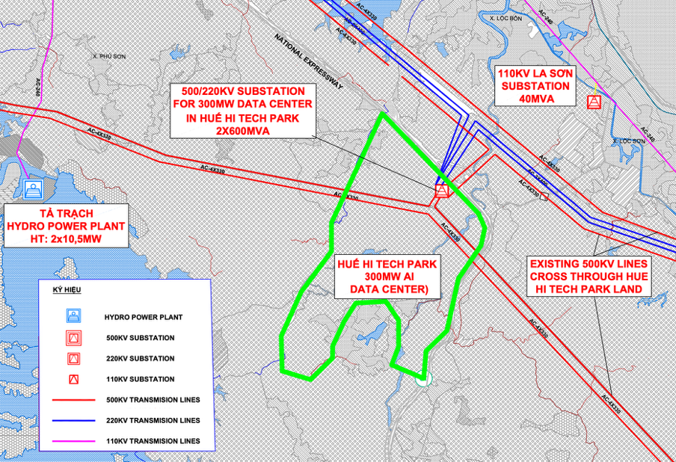

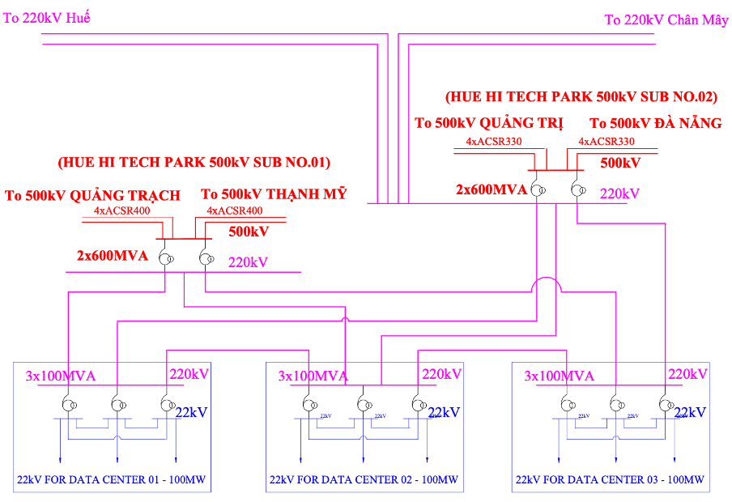

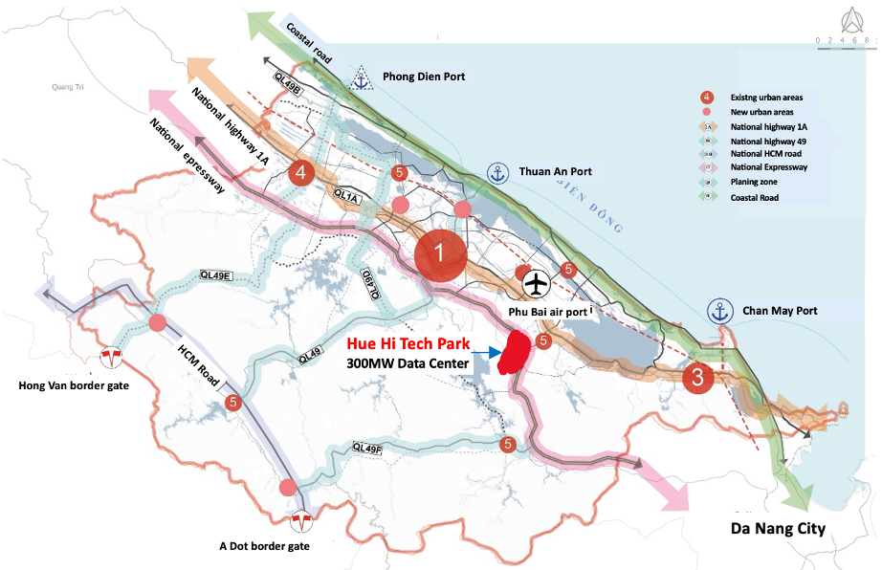

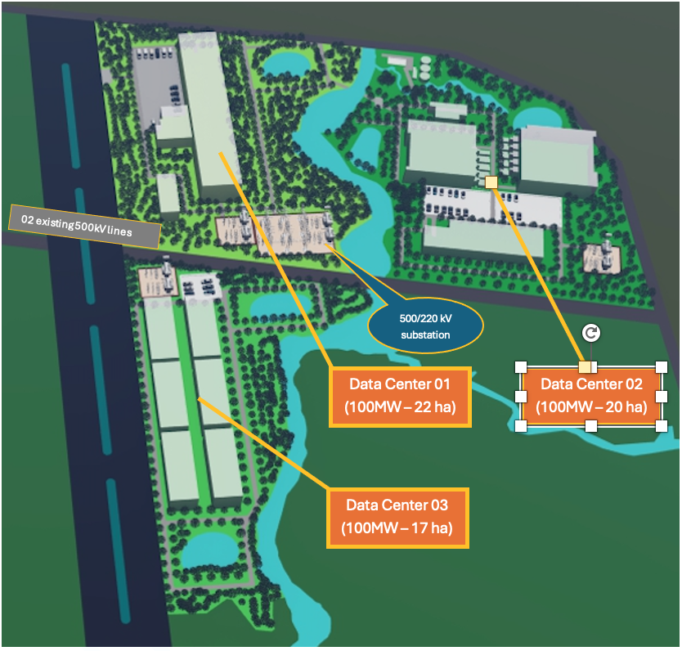

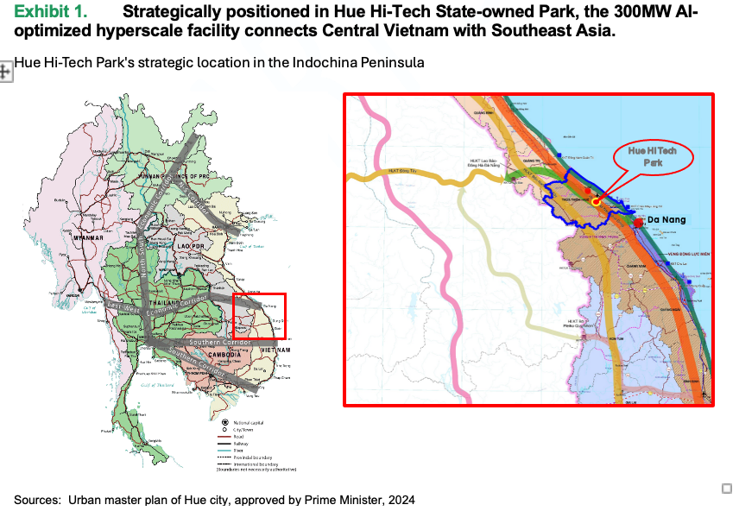

**AI Hybrid Hyperscale Data Center Development in VN**

**Hue City - Executive Brief 2024 - 2025**

**Executive Summary**

A transformative 300MW AI-optimized hyperscale facility, strategically positioned in Vietnam's premier state-owned Hue Hi-Tech Industrial Park, leveraging unique natural cooling advantages and pre-built for the industrial complex 500kV to 220kV ~ 110kV national grid accessibility, featuring dual-circuit 500kV transmission lines crossing directly through the project boundary.

Renewable powered by offshore wind energy under Vietnam's enhanced 2024 DPPA framework, this project introduces a groundbreaking permitting system modeled after Malaysia's successful data center development program.

**Project Highlights**

* **Planned Scale**: 300MW AI-optimized hyperscale facility, 3 phases.
* **Location**: Premium zone within Hue Hi-Tech Park (1081 ha) with highest incentives
* **Power**: Primary offshore wind DDPA and 2N+1 grid redundancy with existing EVN`s 500kV lines cross project boundary
* **Cooling**: Hybrid system utilizing natural valley stream from mountains and advanced submersibles
* **Land**: 100-hectare secured with expansion potential. The land has been designated for data center use under Vietnam's master plan law, ensuring full legal compliance.
* ***Framework****: Enhanced permitting system based on Malaysian Gov`s model*
* **Superior Power Infrastructure**
  + Dual-circuit 500kV transmission lines crossing directly through the project boundary.
  + Connectivity of 500kV to 200kV to 110kV national grid substation
  + 2N+1 Redundancy feeds from independent power plants transmission lines
  + Priority access to national power infrastructure
  + Enhanced grid stability measures

Exhibit 1. Hue Hi-Tech Park's 300MW data center has existing 500kV lines crossing site boundary, with integrated 500/220/110kV substations and 2N+1 redundancy.

Power Architecture: 2N+1 redundant 500/220kV powers 300MW datacenter.